- Buffalo Bills | New York | - Baltimore Ravens | Maryland
- Miami Dolphins | Florida | - Cincinnati Bengals | Ohio
- New England Patriots (Boston) | Massachusetts | - Cleveland Browns | Ohio
- New York Jets | New York | - Pittsburgh Steelers | Pennsylvania
- Dallas Cowboys | Texas | - Chicago Bears | Illinois
- New York Giants | New York | - Detroit Lions | Michigan
- Philadelphia Eagles | Pennsylvania | - Green Bay Packers | Wisconsin
- Washington Redskins | Washington DC | - Minnesota Vikings (Minneapolis) | Minnesota
- Denver Broncos | Colorado | - Houston Texans | Texas
- Kansas City Chiefs | Missouri | - Indianapolis Colts | Indiana
- Oakland Raiders | California | - Jacksonville Jaguars | Florida
- San Diego Chargers | California | - Tennessee Titans (Nashville) | Tennessee
- Arizona Cardinals | Phoenix | - Atlanta Falcons | Georgia
- San Francisco 49ers | California | - Carolina Panthers(Charlotte) | North Carolina
- Seattle Seahawks | Washington | - New Orleans Saints | Louisiana
- St. Louis Rams | Missouri | - Tampa Bay Buccaneers | Florida
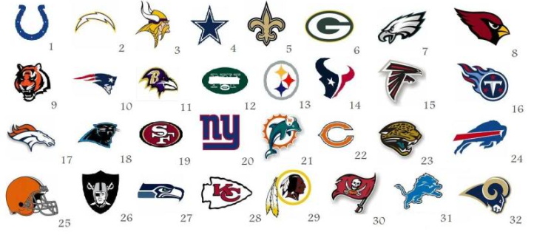
Working in groups or by themselves, EACH student must:
- Grab a blank US map (put your name on it)
- Find each NFL football team’s home city
- Label the city on their map using the table below and the provided maps of major US cities.

