Name: _____________________
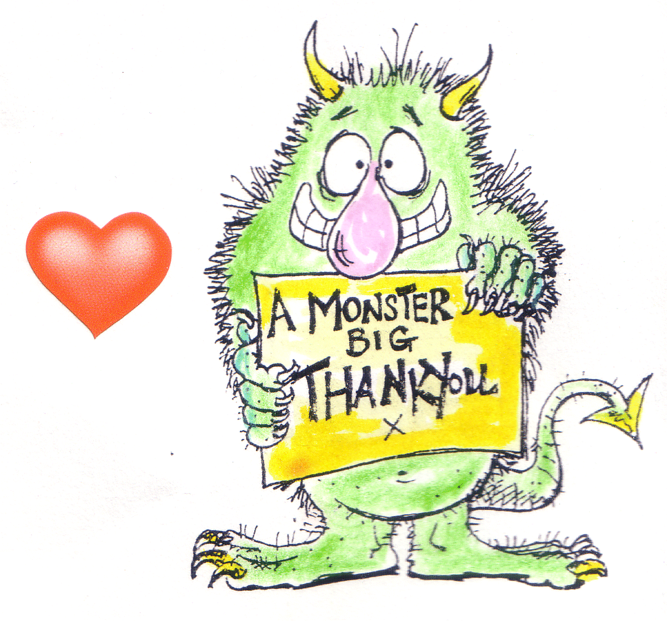
Period: ____________

Manners

Why are people so RUDE?

Rude things kids do to kids at school

Rude things kids do to teachers

Rude things
teachers do to
kids

Why are manners good for you?

Manners I need to work on at school:

1.____________________________________________________________________________
2.____________________________________________________________________________
3.____________________________________________________________________________
4.____________________________________________________________________________
5.____________________________________________________________________________

The one manner I am going to focus on improving is:
1.____________________________________________________________________________

Here is my plan for improving this manner: ________________________________________________________________________________________________________________________________________________________________________________________________________________________________________________________________________________________________________________________

Our class goal is: ____________________________________________________________

IF I FAIL OR FORGET I WILL TRY AGAIN!!!

“If at once you don’t succeed, try, try again.”

