PERSONAL HYGIENE ARTICLE

Keeping your body clean is an important part of keeping you healthy and helping you to feel good about yourself.
Caring about the way you look is important to your self esteem (what you think about yourself). This topic gives you some ideas on looking your best. By the way, you don't need to wear the latest designer clothing to look good. There are other things you can do which are much more important for your "image". | 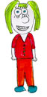

Smelling clean
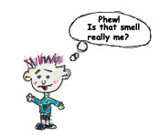 | Have you ever walked into a classroom full of kids when all the windows are closed? PhWew!!  According to the experts young people may sweat but they don't start having body odor (BO) until they reach puberty. That's when special sweat glands under the arms roar into full production pouring out sweat which smells!
OK, so what is the smell that is coming from the kids?

Clothes
Even if you're not heavily into puberty style sweating, clothes can get stained, dirty and generally grubby, so you need to change them often.
Underclothes are right next to your skin and collect dead skin cells, sweat and possibly other unmentionable stains. Overnight bacteria start to work on these stains so your clothes do not smell as nice on the second day of wearing.  Stay away from cigarette smoke as the smell will get into your clothes and hair. Ask your family not to smoke in the house or the car. | 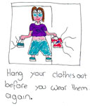
If you have to wear a school uniform then take it off as soon as you get home and hang it up to air before you wear it the next day. Change underclothes often.

Shoes
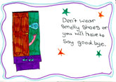 | You spend a lot of time on your feet and your shoes are very close to the place where a very large collection of sweat glands live - your feet!  Sweat gets into your shoes and then bacteria arrive which love the moist leather or fabric so much that they tell all their friends to come round and party!

If you have one pair of shoes for school then try to get them off as soon as you get home so that they can air and dry out overnight. (As you get older somewhere outside the house is a good place!)
If you have more than one pair then use them on alternate days to give them a better chance of drying out.
Keep your shoes clean by brushing, polishing or washing. They will look better, last longer and be less likely to smell.

Feet
Wash your feet well at least once a day.  Dry them carefully, especially between the toes. If the towel is too thick to get in between your little toes, then use a dry face washer (keep it for your feet only). | 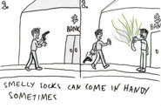
If you go swimming a lot or use public showers, you need to be particularly careful to wash your feet and dry them well. It is a good idea to wear flip flops on your feet too. Lots of other people walk in bare feet in these places and you can easily pick up fungal infections or other problems for your feet, such as warts!

Using 'smell nice' products
If you are in middle school you may want, or feel you need, to start using a deodorant or anti-perspirant under your armpits. Some people have problems with perfumes, which can be a trigger for headaches, asthma or hay fever, so don't spray them around in the washroom or change-room.
Remember: nothing smells better than clean skin. Perfumes are not a good substitute for a shower or wash.
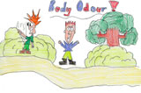 | You may want to use special innersoles in your shoes, which can be taken out and washed, making the shoes smell less.  You may want to use foot powder or talcum powder on your feet and inside your shoes. This can help too.
Most sneakers or running shoes will survive being washed by hand or even in the washing machine.

Hair
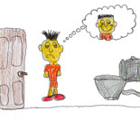 | The hair follicles [which the hair grows from] produce oil which keeps the hair smooth. You also have sweat glands in your scalp, and dead skin cells come off the scalp. The oil, sweat and dead cells all add together and can make hair greasy and look dirty unless you wash it regularly.
To keep your hair clean:
 | wash regularly with shampoo (cheap ones are often as good as very expensive ones). | 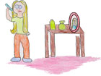
 | massage your scalp well. This will remove dead skin cells, excess oil and dirt.
 | rinse well with clear water.
 | conditioner is helpful if you have longer hair as it makes the hair smoother and easier to comb, but hair doesn't need to have conditioner.
 | use a wide toothed comb for wet hair as it is easier to pull through.

Teeth
- You should brush your teeth twice a day - after breakfast and before you go to bed.
- During the day, fill your mouth with water and swish it around to get rid of anything sticking to your teeth.

Dr Kim says:
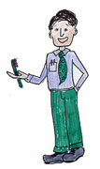
"With a clean body, clean hair, clean clothes and shoes, you will feel good and your friends will be happy to be near you. Keep your fingernails and toenails short and clean too."

KEEPING CLEAN
Mum said to have a shower,
And wash my hair well too.
I've been in here for ages,
I think that that will do.
Uh, oh, the towel's dirty,
Maybe I really oughter,
Next time I have a shower,
Stand underneath the water.
BH

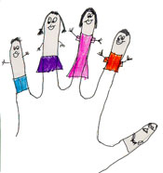 | Some advice from Ben in Grade 6  "Personal hygiene is very important because no-one likes to be close to a person who stinks and is dirty. So, whoever you are and wherever you go remember:  Wash your hands before you eat and your feet before you sleep."

Did you know?
Most homes have showers or baths and hot water which comes out of the tap. In the 'olden' days all water had to be boiled on a fire or wood stove, then carried to a washbowl or bath. Often families would only have a bath once a week (or less often) when all the family would use the same bath water, one after another. (Wouldn't have liked to be the 'not so lucky last', would you?)
In the even older days people didn't wash much at all! Some people thought that washing yourself could make you weak. People would wear scent and stick their noses into a bunch of flowers if the smell was bad when they walked through the streets. Very few adults had a full set of teeth.
Nowadays things are very different for most people. Even when we are travelling or camping we can still keep clean and fresh thanks to campsite showers and moisturized hand and face wipes.
NAME_____________________
PERIOD____________________
SCORE___________/10

PERSONAL HYGEINE FOR MIDDLE SCHOOL Reading Worksheet

bacteria
clean
designer clothing
good
gross
healthy
self esteem
skin cells
soap
toothpaste
underclothes
wash

DIRECTIONS: Read the article to help you fill in the blanks below. Use the word from the box above, and cross them off as you go.

- Keeping your body_____________ is an important part of keeping you____________ and helping you feel__________________ about yourself.

- Caring about the way you look is important to your ________________ .

- You don't need to wear the latest_______________ to look good.

- Your underclothes are right next to your skin and collect dead ____________ , sweat and possibly other _____________ stains.

- Overnight _________________ start to work on these stains so your clothes do not smell as nice on the second day.

- Change _____________ often.

- What do you think is the biggest hygiene issue in middle school?

