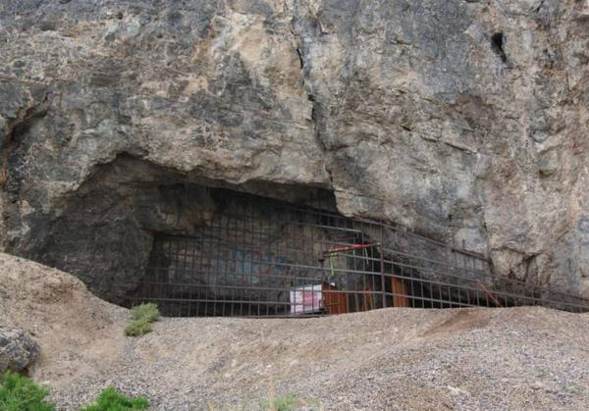
Danger Cave

Much of what we don’t about Utah’s prehistoric people comes from Danger Cave. Danger Cave is in the West Desert near Wendover.
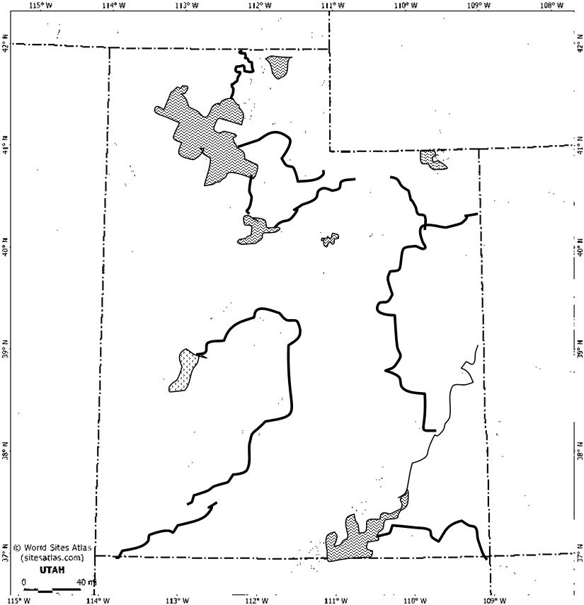

Danger Cave

Artifacts such as; beetle wings, textiles, leather scraps, pieces of string, nets of twine, basket fragments, and bone and wood tools such as knives, weapons, and millstones have been found here.
The age of the oldest material was over 11,000 years ago. Dog bones found at the cave were about 9,000 years old.
This means Danger Cave is one of the oldest human sites in the Great Basin.
Evidence at the cave suggests that the desert population at the times was sparse, with small family units of about 20-30 people in each group.
The people were hunter-gathers. They gathered seeds, roots, and nuts, roasted their meats, and used the cave as shelter.

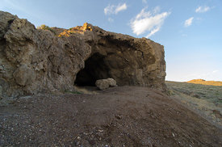
Hogup Cave

Recognized as one of the state’s most important prehistoric sites.
Located in the West Desert, beyond the shores of the Great Salt Lake.
Hogup Cave

There’re two caves. One is the size of a large house; the second one is half that size.
This cave had been used by many different cultures over a period of about 8,000 years. The cave provided shelter to many people for thousands of years.
The first culture used the cave to harvest pickleweed to preserve their food.
The second culture used the cave as a temporary home and left moccasins, jewelry, and other artifacts.

Fremont
Fremont got their name from the Fremont Valley where most of their sites were first discovered.

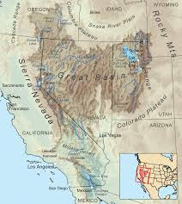
Fremont lived in
the Great Basin
Region. Because
the Great Basin
Region is so big a
variety of Fremont
cultures developed.
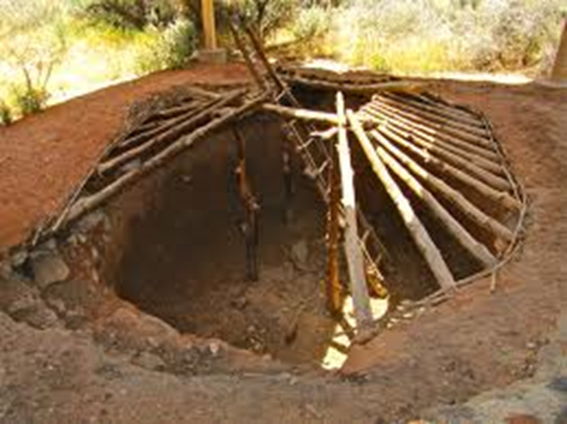
The Fremont
lived in
pit houses.
They lived in small villages that were usually close to the water. They built irrigation systems to carry water from the river to their crops. They would then store their food in their pit houses to last the whole winter.
They were farmers, hunters, and gatherers (just depends on where they were living exactly). They usually ate things such as; corn, beans, squash, berries, small game, and deer.
They made coiled gray pottery, baskets, clay figurines that looked like people, and rock art.
Both men and women wore ceramic turquoise necklaces and earrings. They often decorated their clay figurines with jewelry as well.

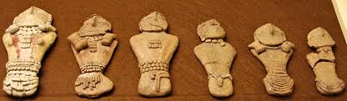

Historians do not know what happened to the Fremont, they just disappeared.

Anasazi
Anasazi means “ancestor”. It is believed that they’re ancestors of the Pueblo.
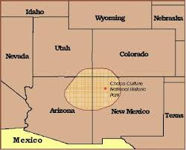
They lived in
the South/East
part of Utah in
the four corners
region.

The Anasazi are famous for their incredible cliff dwellings they lived in.
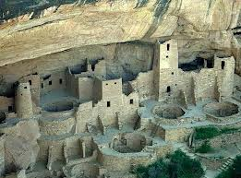
They would stay put in one place at one time but their ancestors before them were none for moving around.
Their homes were very complex with hundreds of rooms that often times had painted walls. They would have to carry water and supplies up hundreds of feet where their homes were.
They were farmers, gathers, and hunters. They ate the following things; corn, squash, beans, berries, sego lilly bulbs, pine nuts, wild onion, deer, rabbit, mountain sheep, and bison.
Things they made were;
baskets, pottery, and tools.
They made beautiful pottery with zigzag designs in them.
Historians do not know what happened to the Anasazi, they just disappeared.

Paleo-Indians
They’re the earliest people of North America. Their name means; “very ancient”. The people were believed to live in the Four Corners Region and maybe around Danger Cave.

They used hard rock to makes spears.
They hunted animals as well as gathered seeds, roots, nuts, and other wild plants to eat.
They never settled in one place for long because they had to move around for their food.

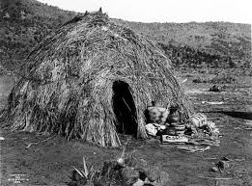
They lived in
small shelters
called
wicki-ups.

Archaic-Indians
Archaic-Indians means “Ancient Indians”. They lived here for about 6,000 years.
They did not live in one place. They moved around often for food and to adapt to the weather. Summers they usually lived in cool mountains and in Winter they usually lived in deserts. They lived all over Utah.
They lived in
small shelters
called
wicki-ups.
They made baskets from plant fibers. These were important for gathering seeds. They also made tools for hunting such as the atalatl, nets, and spears.
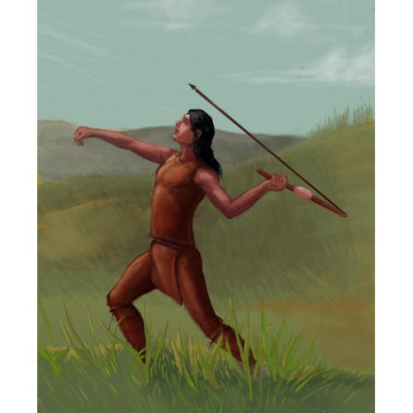
They ate things such as; deer, antelope, rabbits, birds, sego lily bulbs, roots, rice grass, and bulrush.

