Name: _________________________________________________________ Period: ______
Prehistoric Indians
Using pages 47-53 in the textbook or information from our gallery walk in class complete the chart about each group. *There might be some boxes that you can’t fill out because we don’t have that information, leave these blank.
 | Where they lived | Shelter | Food | Tools & Crafts
Danger Cave
Hogup Cave
Paleo-Indians
Archaic Indians
Anasazi
Fremont
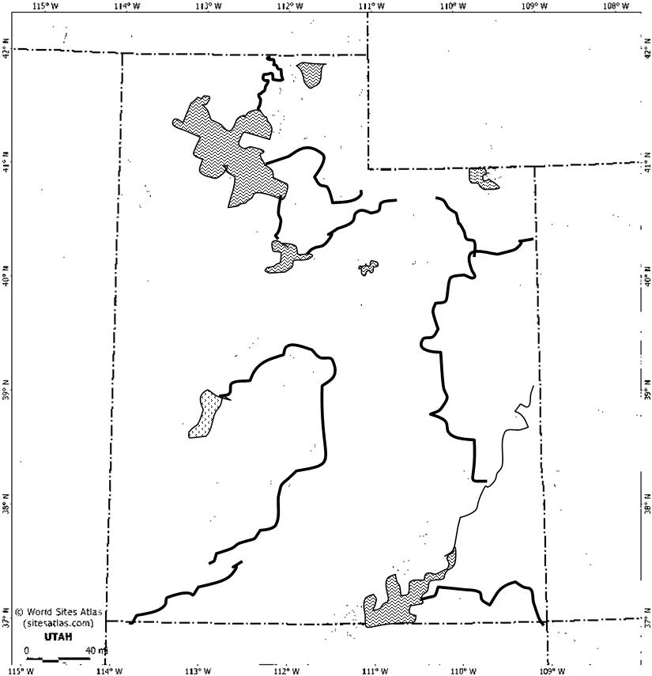
Key
Using pages 47-53 in the textbook or pictures from our gallery walk label where each group of people lived. Be sure to include a key.

