Name: __________________________________________________________ Period:____________
Types of Maps
Write at least three important things about each type of map.
Type of Map | Important Information about the type of map | Picture of map type
Political Map | 1.  2.  3. | 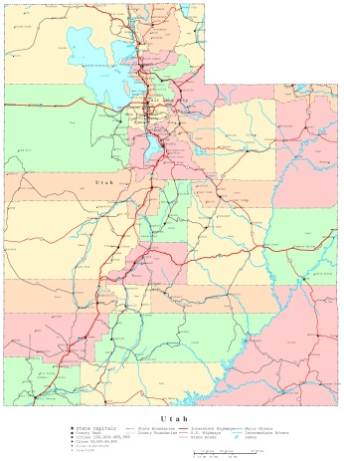
Road Map | 1.  2.  3. | 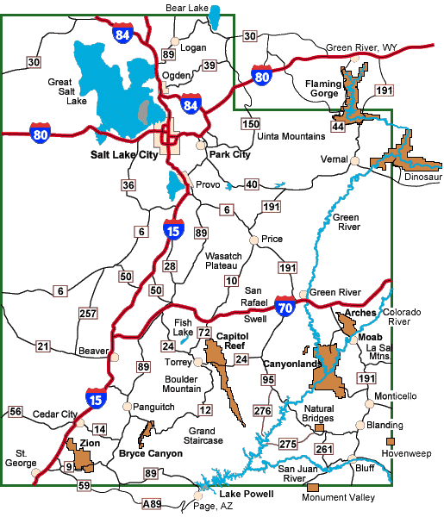
Thematic Map | 1.  2.  3. | 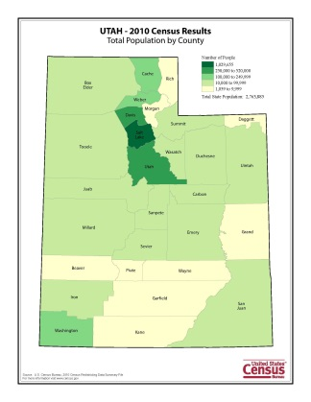
Physical Map | 1.  2.  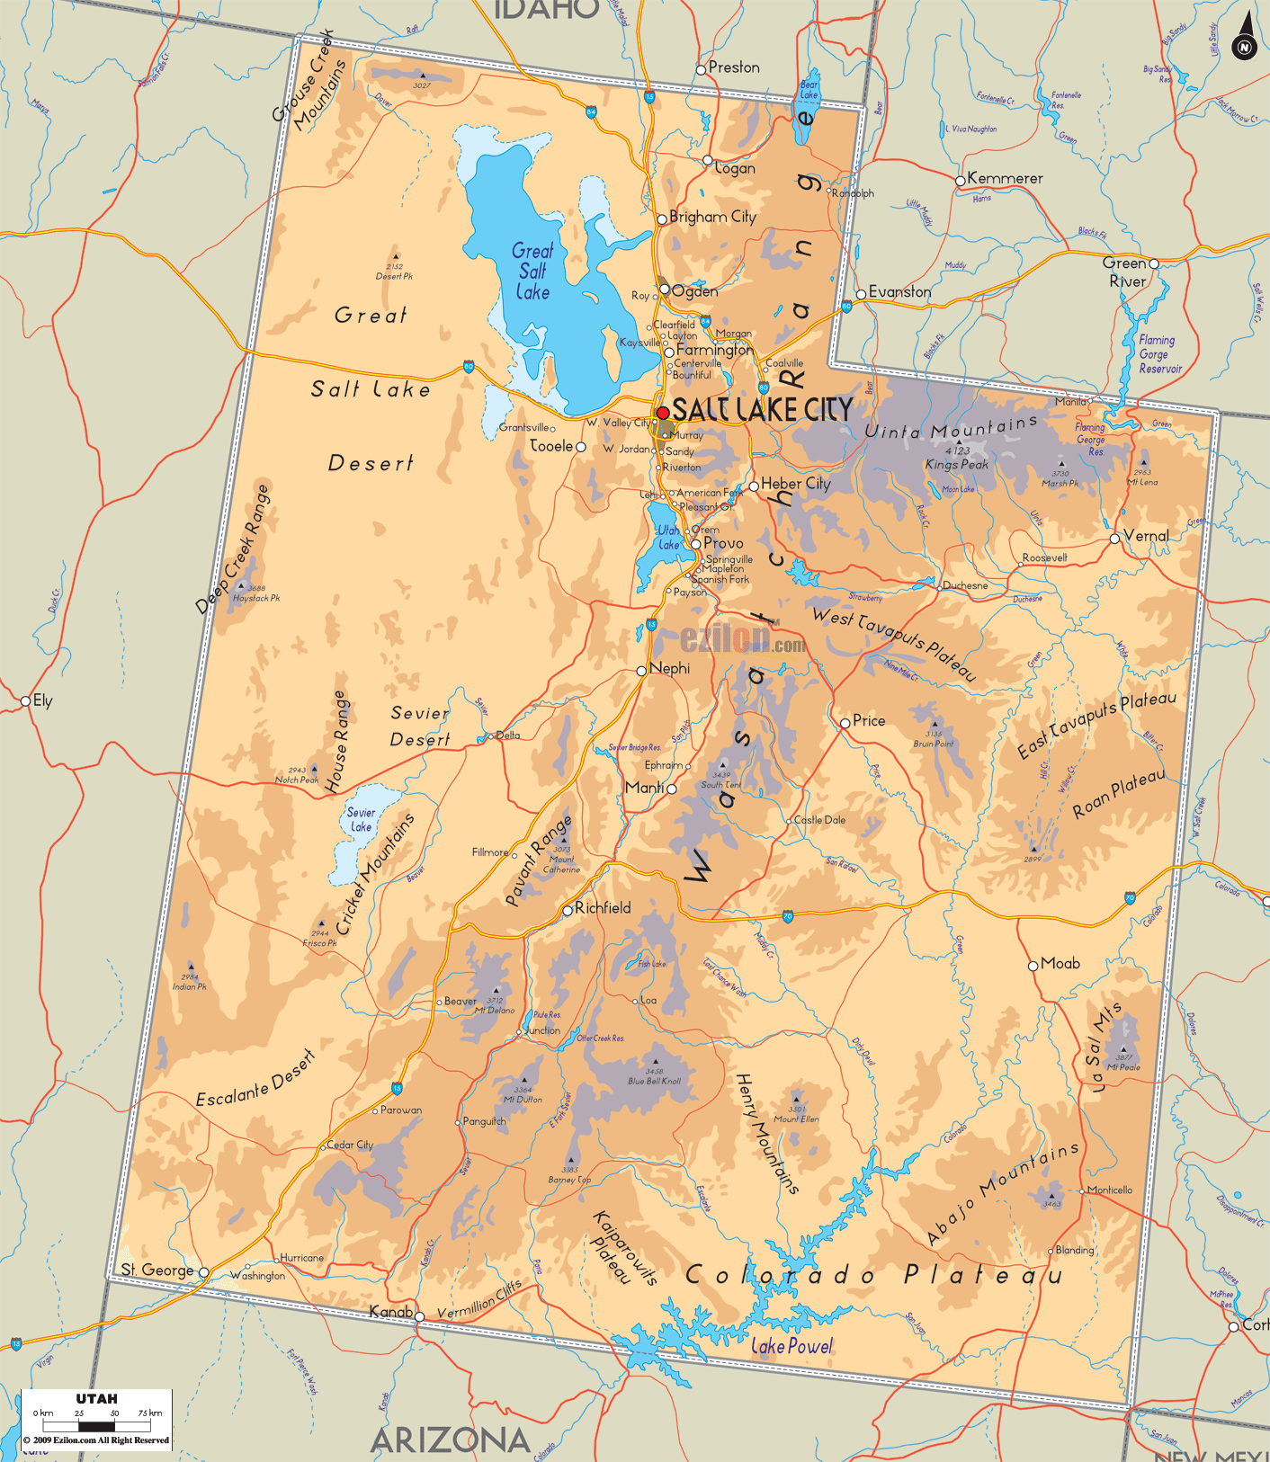  3.
Climate Map | 1.  2.  3. | 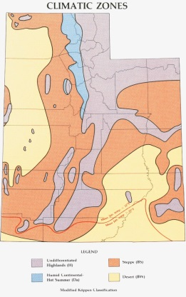
Topography Map | 1.  2.  3. | 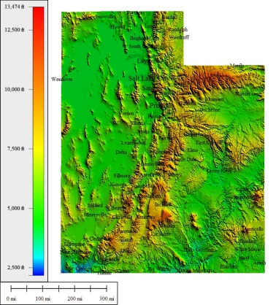
Economic or Resource Map | 1.  2.  3. | 