Name:___________________________________________________________Date:_________
Utah War
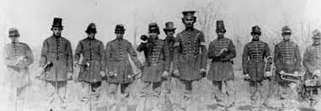
Reading from textbook | Summary
The Utah War (pg. 150)

President Buchanan Prepares for War (pg. 151)

Utah Territory Prepares for War (pg. 152)

Johnston’s Army Is Stopped By Winter Snow, “Buchanan’s Blunder”, and the Move South (pg. 154)

Thomas Kane and Governor Cumming Help End The War (pg. 154-155)

The End of Isolation and Camp Floyd (pg. 156)

The Soldiers Leave and Governor Cumming Leaves (pg. 157)

Diversity-A Lasting Impact of the Utah War (pg. 157)

